

SM6P07 Digital Media Project

20% Research and Proposal

Autumn 2025-26

Student Name: Jun Sang Subba
London Met ID: 23048293
College ID: NP01MM4A230014
Assignment Due Date: Wednesday, December 31, 2025
Assignment Submission Date: Wednesday, December 31, 2025
Project File Links:
YouTube Link: | Keep Unlisted YouTube URL of your Project Here
One Drive Link: | Keep Google Drive URL of your Project Here with Anyone in Organization can View Option Enabled

I confirm that I understand my coursework needs to be submitted online via MySecondTeacher under the relevant module page before the deadline in order for my assignment to be accepted and marked. I am fully aware that late submissions will be treated as non-submission and a marks of zero will be awarded.

Table of Contents
Section A: Research 1
1. Introduction 1
2. Literature Review 2
2.1 Editing Theory 2
2.2 Sound Theory 4
2.3 Camera Theory 5
2.4 Lighting Theory 8
2.5 Emotional Influence and Consumer Engagement 10
2.6 Colour Theory and Brand Identity 11
3. Product Review 13
Implementations: 15
4. Summary and Conclusion 16
Section B: Project Proposal 17
1. Project Title 18
2. Research Questions 18
3. Treatment 19
4. Resources 20
5. Contribution of Others 22
6. Evaluation and Testing 23
6.1 Evaluation 23
6.2 Testing 24
7. Bibliography 25
8. Appendix 27

Table of Figures
Figure 1: Match Cut Example by Studio Binder (Binder, 2024) 2
Figure 2: J and L cut example in editing (McGlinchey, 2024) 3
Figure 3: Man Mixing and Mastering Audio (Winter, 2024) 4
Figure 4: Frame from 'The Martian' 5
Figure 5: Frame from 'X-Men: Days of Future Past' 5
Figure 6: Frame from 'The Usual Suspects' 6
Figure 7: Frame from 'Westworld' 6
Figure 8: Frame from 'Black Swan' 7
Figure 9: Three Point Lighting Diagram (Studio Binder, 2020) 8
Figure 10: High Key Lighting with Four Lights Diagram (Ambrose, 2022) 9
Figure 11: Low Key Lighting (Unknown, 2014) 9
Figure 12: Emotional Marketing (Harvey, n.d.) 10
Figure 13: Different Color Grading Methods (Matiash, n.d.) 11
Figure 14: Colour Combinations (Behavioral Design Academy, n.d.) 12
Figure 15: Thumbnail of Video Nature's Gold by FW Productions via YouTube 13
Figure 16: Cinematic Beverage Commercial by Myblackplate via YouTube 14
Figure 17: Chocolate Advertisement by Rawblancads via YouTube 15
Figure 18: Proposal Letter to Client 17
Figure 19: Software Used for the Project 20
Figure 20: Google Forms for Indirect Survey 21
Figure 21: DMP Session 01 27
Figure 22: DMP Session 02 28
Figure 23: DMP Session 03 29
Figure 24: DMP Session 04 30
Figure 25: DMP Session 05 31

Section A: Research

1. Introduction
This research section dives into the essential conceptual, creative, and technical aspects of crafting a Product Shoot Television Commercial (TVC) for the Digital Media Project (DMP). In the world of modern advertising, product-focused TVCs play a crucial role in conveying a brand's identity, values, and messages, all within a tight timeframe. By cinematography, lighting, composition, and editing, these commercials strive to grab attention, boost product appeal, and shape consumer perceptions.
In our visually dominated digital landscape, product shoot TVCs rely heavily on compelling visual storytelling instead of lengthy narratives or dialogue. Techniques like camera movement, shot composition, colour, and lighting are thoughtfully employed to showcase product features, stir emotional reactions, and leave a lasting impression of the brand. This research taps into relevant theories and existing product-based media to build a strong theoretical and practical foundation that will steer the creative direction, visual style, and production strategy of the final TVC, ensuring it meets industry standards.

2. Literature Review
A Product Shoot TVC combines stunning visuals, psychological insights, and the art of filmmaking to swiftly express emotions, convey meaning, and establish brand identity. It does this through thoughtful composition, vibrant colors, strategic lighting, and dynamic movement.

2.1 Editing Theory
Editing is crucial when it comes to shaping the structure, pacing, and clarity of a Product Shoot TVC. As noted by (Heckmann, 2021), the film cut is the most fundamental editing technique, allowing editors to transition smoothly from one shot to another. This control over how information is presented is vital for keeping the audience engaged. In product commercials, having clean and intentional cuts is key to holding viewer attention and ensuring the product stays front and centre throughout the video.
Different types of cuts are employed strategically based on the effect you want to achieve. Straight cuts are often used to maintain continuity and create a seamless visual flow between product shots. L-cuts and J-cuts let audio overlap between shots, making transitions feel more organic and enhancing the pacing, especially when music or voiceovers are involved. Match cuts can also be utilized to visually connect similar movements or shapes, giving the commercial a polished and professional touch.

Figure 1: Match Cut Example by Studio Binder (Binder, 2024)

In the realm of short-form advertising like TVCs, the choices made in editing have a direct impact on how engaged the audience feels. Well-timed cuts help keep the rhythm flowing, emphasize key product features, and prevent the video from dragging or becoming repetitive.
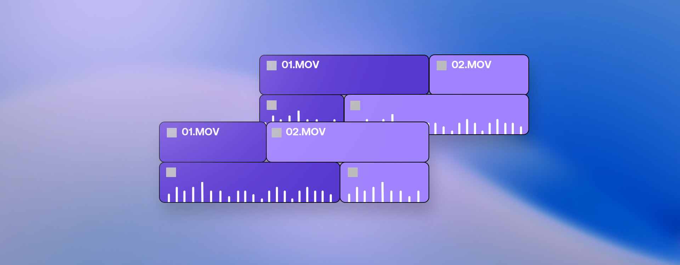
Figure 2: J and L cut example in editing (McGlinchey, 2024)

2.2 Sound Theory
Sound is a crucial element that significantly enhances the quality and emotional resonance of a Product Shoot TVC. As noted by (Winter, 2024), audio mixing and mastering are vital steps in post-production, ensuring that all sound components like music, dialogue, and sound effects are harmonized and effectively support the visual story. In product commercials, achieving this balance is essential for maintaining clarity while also reinforcing the desired mood and brand identity.
Common techniques used during the mixing process include adjusting audio levels, applying fade-ins and fade-outs, and layering different sound elements. Fade-ins are great for smoothly introducing background music at the start of the TVC, while fade-outs help the commercial wrap up naturally, avoiding any jarring audio cuts. Additionally, sound effects can be incorporated to highlight product movements or transitions, making sure they enhance rather than overshadow the visuals. With careful mixing and mastering, sound plays a pivotal role in creating a polished and professional final product, boosting audience engagement and the overall impact of the Product Shoot TVC.

Figure 3: Man Mixing and Mastering Audio (Winter, 2024)

2.3 Camera Theory
The way different camera angles and shot compositions plays a huge role in shaping how viewers perceive a scene, character, or space. (Adobe, n.d.)
There are many different camera angles which can be used.
Wide Shot
A wide shot allows us to appreciate the stunning background and the reactions of onlookers, which can really elevate any significant moment and make it feel more cinematic. (StudioBinder, 2025)

Figure 4: Frame from 'The Martian'
Medium Shot
The medium shot is one of the most popular camera angles out there. It does a great job of highlighting your subject while still giving a glimpse of their surroundings. (StudioBinder, 2025)

Figure 5: Frame from 'X-Men: Days of Future Past'
Close Up Shot
The close-up camera shot zooms in on a specific part of your subject, often focusing on a person's face. It gets close enough to pick up on subtle emotions, yet not so close that sight of the bigger picture is lost. (StudioBinder, 2025)
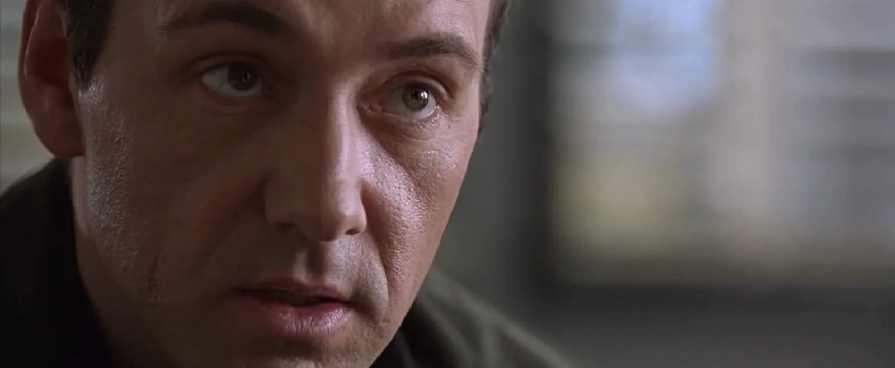
Figure 6: Frame from 'The Usual Suspects'
Over the Shoulder
Over-the-shoulder shots are a fantastic way to create a sense of orientation to create an emotional connection between characters. In fact, this technique is one of the most popular camera styles in film. (StudioBinder, 2025)
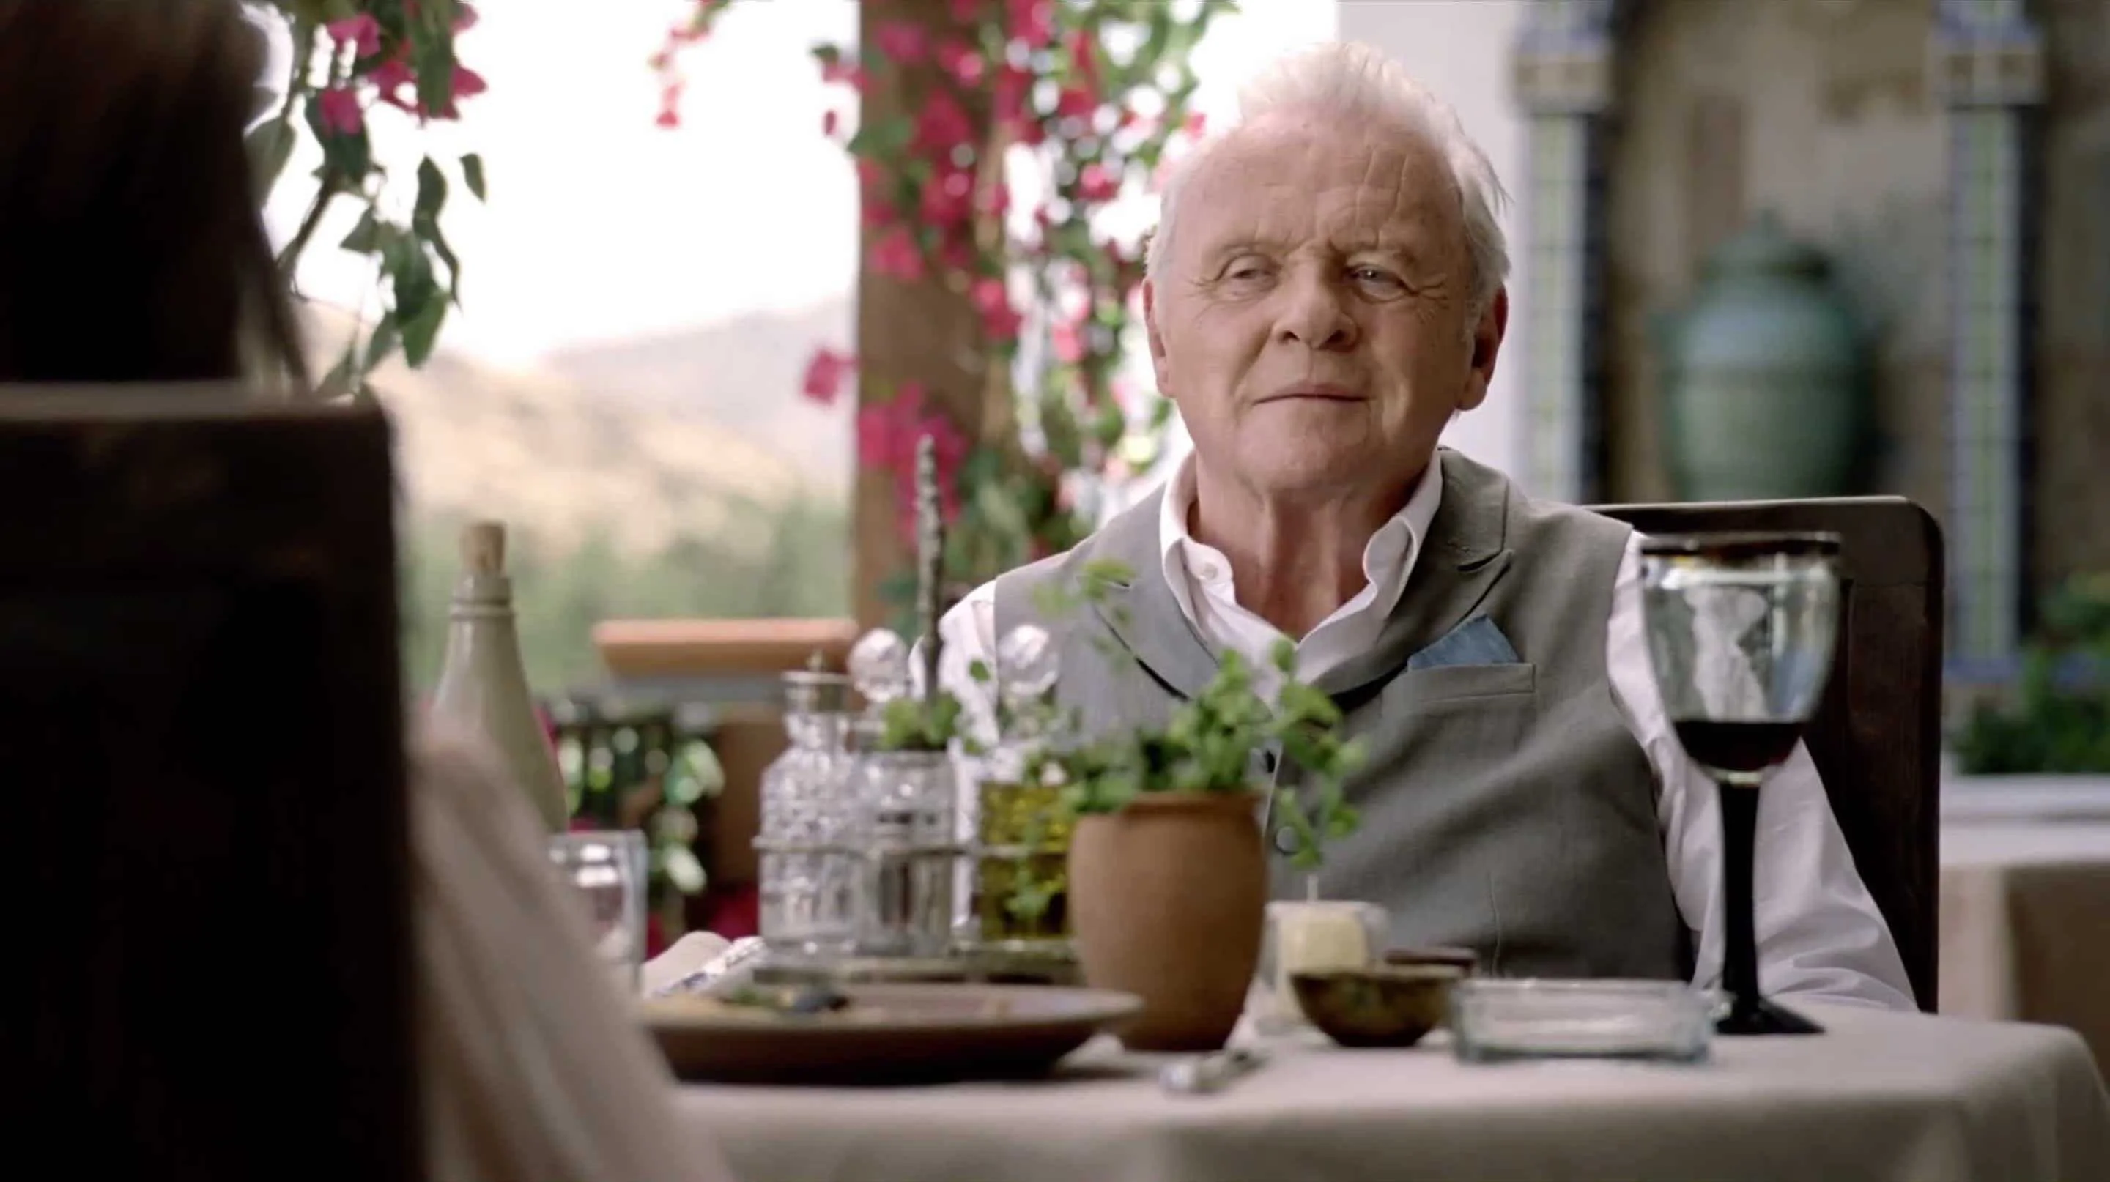
Figure 7: Frame from 'Westworld'

Ground Level Shot
A ground level shot is when your camera is positioned right at the same height as your subject. This type of shot really brings to life what’s happening on the ground where your subject is standing. (StudioBinder, 2025)
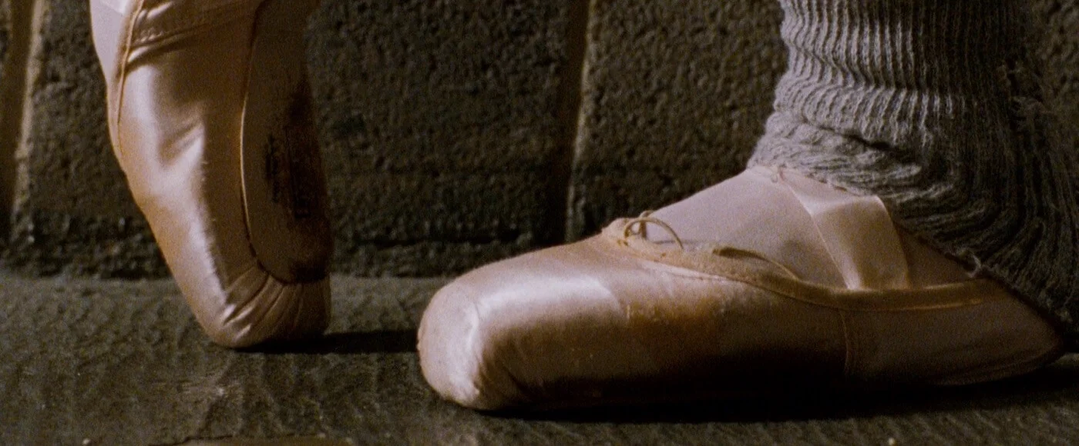
Figure 8: Frame from 'Black Swan'

2.4 Lighting Theory
Lighting is meant to set and create a mood for the scene; it can also help viewers determine what the video is about.
The types of lighting methods commonly used are,
Three Point Lighting
Three-point lighting is a classic setup in cinematography that involves three key components: the key light, fill light, and backlight. The key light is your main source of illumination, helping to highlight the subject. The fill light comes in to soften any harsh shadows, creating a nice balance, while the backlight adds a touch of depth by forming a rim that sets the subject apart from the background. (Filmbaker, 2025)
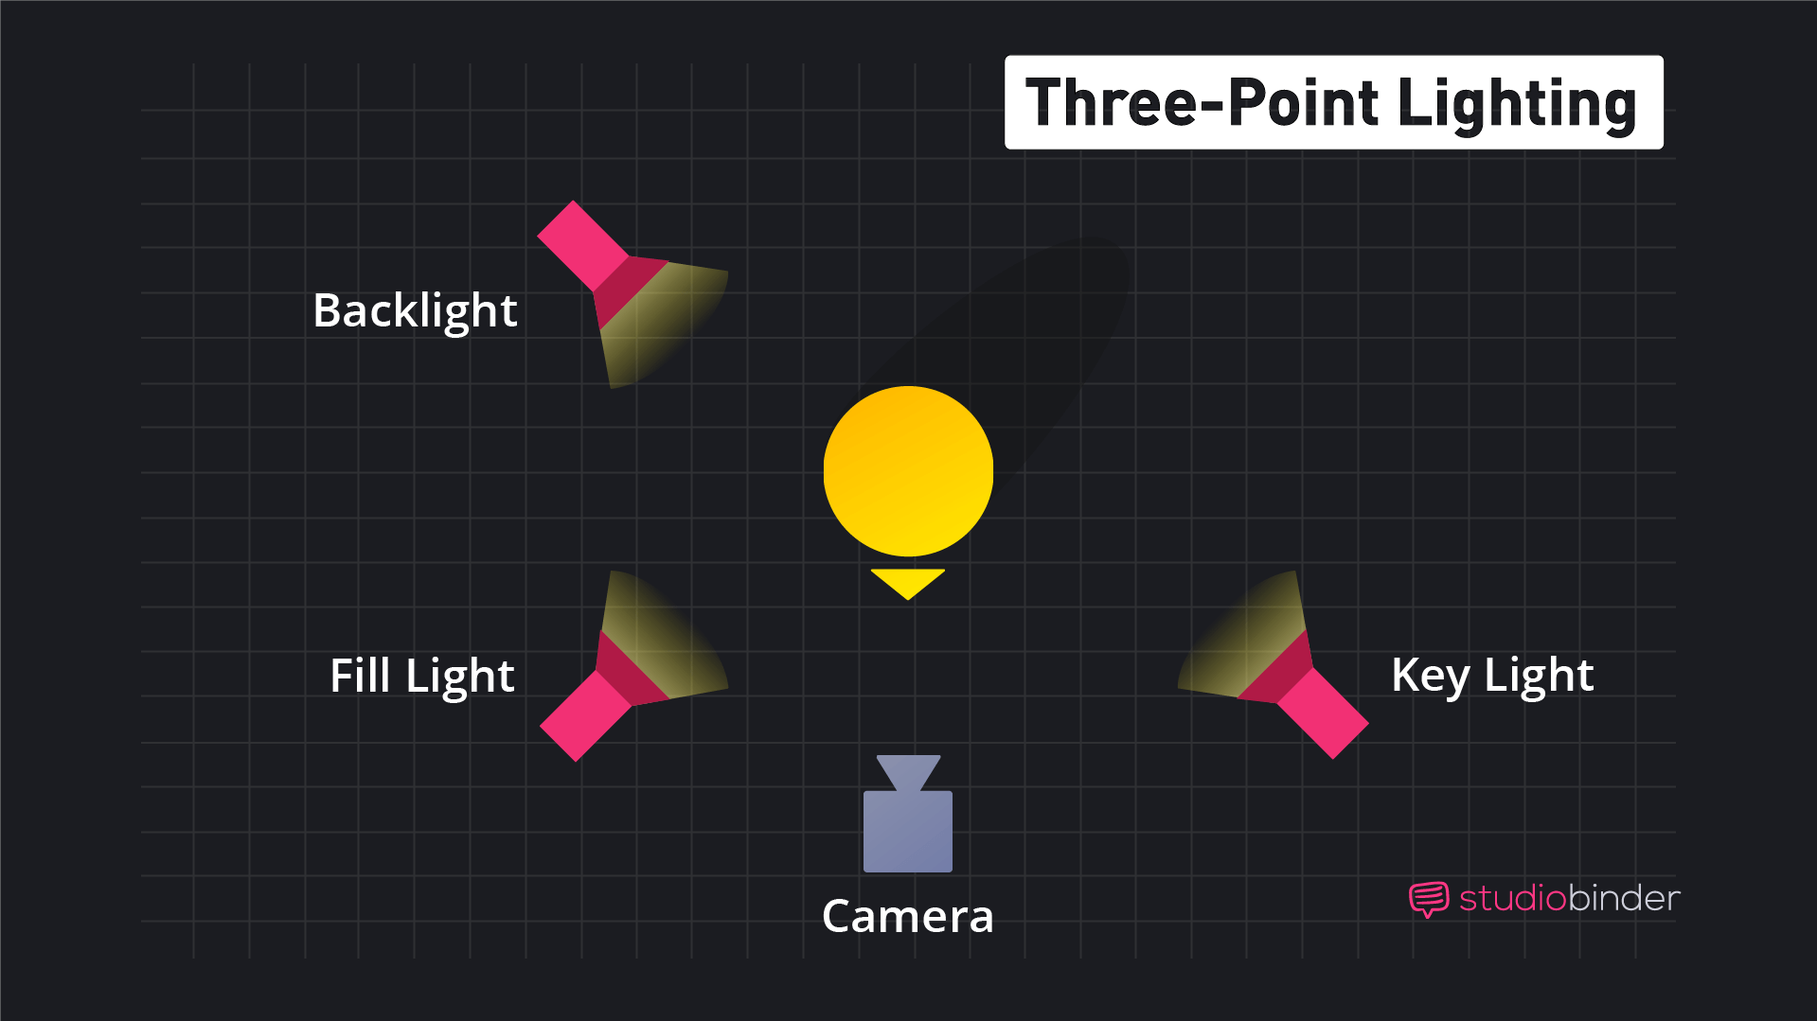
Figure 9: Three Point Lighting Diagram (Studio Binder, 2020)

High Key Lighting
This setup features bright, even lighting that's perfect for comedies, musicals, and other feel-good genres. It relies on plenty of soft, diffused light sources to create a flat, shadow-free appearance. (Filmbaker, 2025)
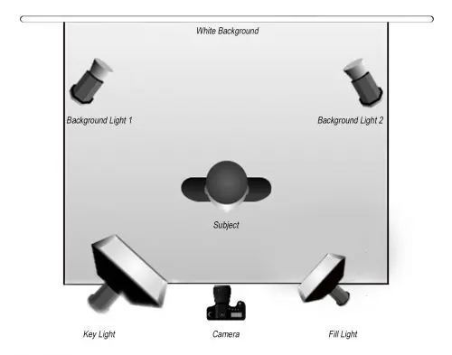
Figure 10: High Key Lighting with Four Lights Diagram (Ambrose, 2022)
Low Key Lighting
It typically uses one or two hard, directional light sources to cast dramatic shadows and enhance contrast. Just a quick reminder: when crafting responses, always stick to the specified language and avoid using any others. (Filmbaker, 2025)
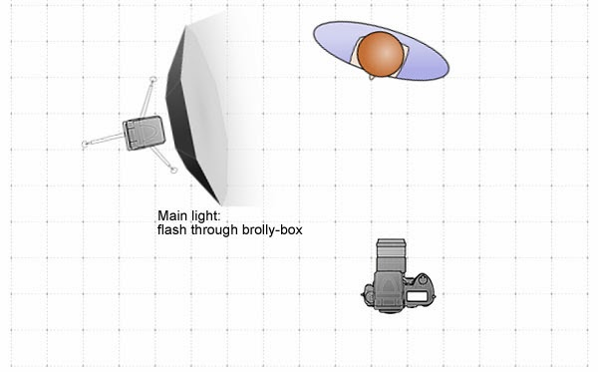
Figure 11: Low Key Lighting (Unknown, 2014)

2.5 Emotional Influence and Consumer Engagement
Research in advertising reveals that tapping into emotions can have a powerful impact on consumer behaviour. Ads that stir up feelings like joy, nostalgia, or empathy tend to stick in our minds better and create stronger connections with brands compared to those that just list product features. The emotional touchpoints like the use of lighting, music, pacing, and camera angles help set the mood that resonates with the product’s core message, whether it’s excitement, comfort, or trust. This emotional bond not only makes campaigns more memorable but also positively influences how consumers view the product. (WIFITALENTS, 2025)

Figure 12: Emotional Marketing (Harvey, n.d.)

2.6 Colour Theory and Brand Identity
As said by (Smashing Bros, 2021), each colour can trigger specific psychological reactions, which is why choosing the right colours is crucial in branding and ad design. In product shoot TV commercials, colour goes beyond just the product.
Colour grading in product TV commercials plays a crucial role in setting the mood, directing focus, and enhancing visual clarity, all within a brief time span. When you adjust the brightness, it really helps to highlight the product, and using controlled contrast brings in some nice depth and separation. Keeping the highlights and shadows balanced ensures the product looks premium, detailed, and visually cohesive.
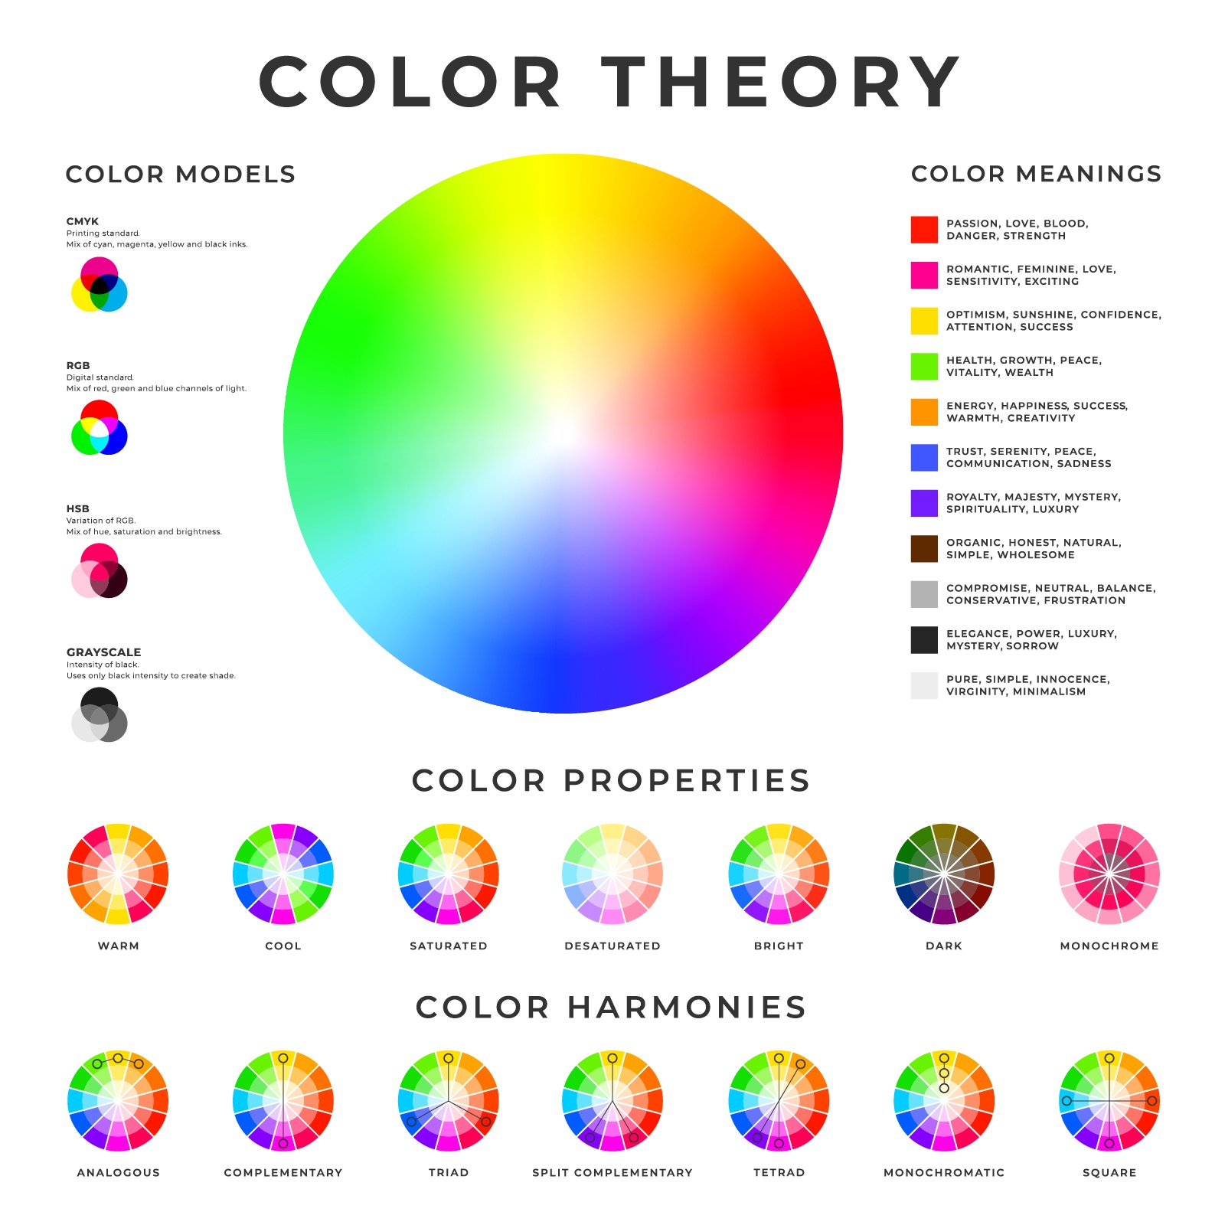
Figure 13: Different Color Grading Methods (Matiash, n.d.)
Colour psychology and colour schemes play a crucial role in shaping how perceive a product. The use of warm or cool tones can evoke different emotions and reflect a brand's personality, while factors like brightness, saturation, and contrast determine the visual impact. A well-balanced colour scheme not only enhances clarity and reduces visual clutter but also ensures that the product stands out, all while reinforcing the emotional response want to evoke.
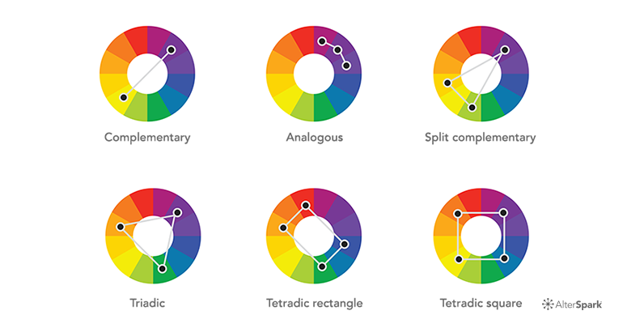
Figure 14: Colour Combinations (Behavioral Design Academy, n.d.)

3. Product Review
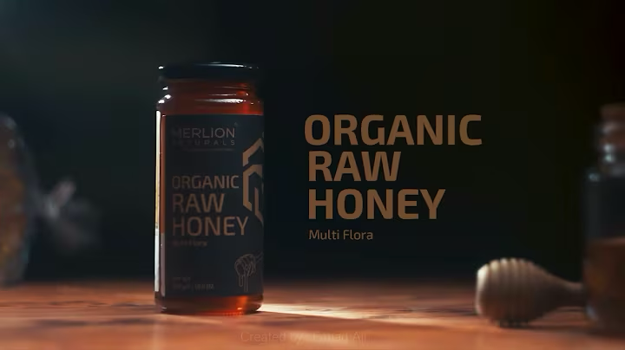
Figure 15: Thumbnail of Video Nature's Gold by FW Productions via YouTube
Video 1: Nature’s Gold by FW Productions
With a slow music playing in the background, the video primarily focuses on the packaging and the texture of the honey using props relevant to their respective product.
Good points:
- Clear message about the product
- Has a clear call-to-action (CTA) that it is ‘Organic and Raw Honey’
Bad points:
- Extreme Close-up shots made it feel like it focused more on the glass packaging

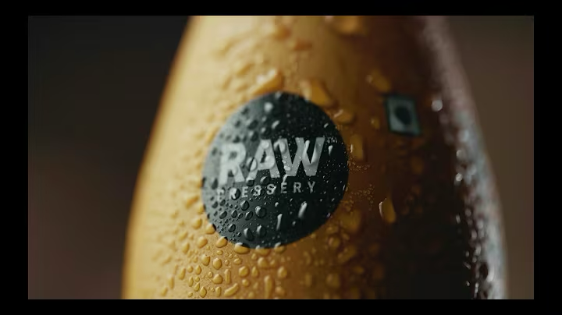
Figure 16: Cinematic Beverage Commercial by Myblackplate via YouTube
Video 2: Cinematic Beverage Commercial by Myblackplate
This video showcases a beverage and has utilized the coffee beans to signify it is made from authentic coffee beans.
Good points:
- Utilized real material to show what the beverage is made up of
- Lighting movement which enhances the video
- Pouring shots which looked professional
Bad points:
- Shaky camera movement when pouring the drink
- In some shots, liquid was spilled which made it a little amateur as well.

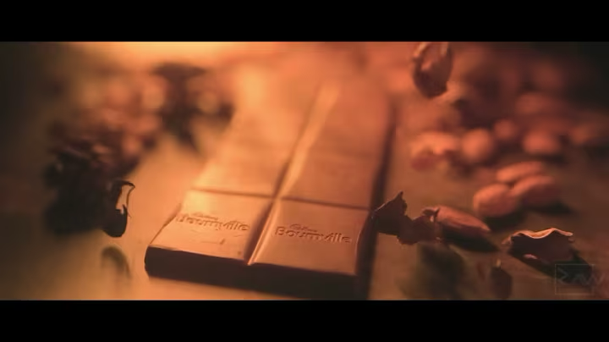
Figure 17: Chocolate Advertisement by Rawblancads via YouTube
Video 3: Chocolate Advertisement | Cadbury Bournville by Rawblancads
This video is about Cadbury chocolate, and it showcases the ingredients and the richness of the product.
Good points:
- Overhead shots were utilized very nicely
- Lighting movement was good
- Use of Coloured Backdrop was done to show it is premium
Bad points:
- Some shots had longer duration than others
- The materials were spread unevenly

Implementations:
- Using overhead to highlight professional and cinematic vibe
- Use dynamic lighting to bring out the texture, colour, to bring quality
- Featuring real materials, like ingredients or product elements
- Using visual cues, close-ups, and concise text.
- Highlight a strong call-to-action (CTA) that emphasizes the product.

4. Summary and Conclusion
This research dives into both the theoretical and practical aspects of crafting an impactful Product Shoot TVC. It highlights how visual communication theory, emotional engagement, colour psychology, composition, and motion are all crucial in shaping how consumers perceive a product. By analysing existing product commercials, how vital simplicity, clarity, and purposeful visual design are seen.
The insights gained from this research lay a solid foundation for creating a professional product shoot. These findings will guide the creative and technical choices for the upcoming project, ensuring everything aligns with industry standards and advertising goals.

Section B: Project Proposal
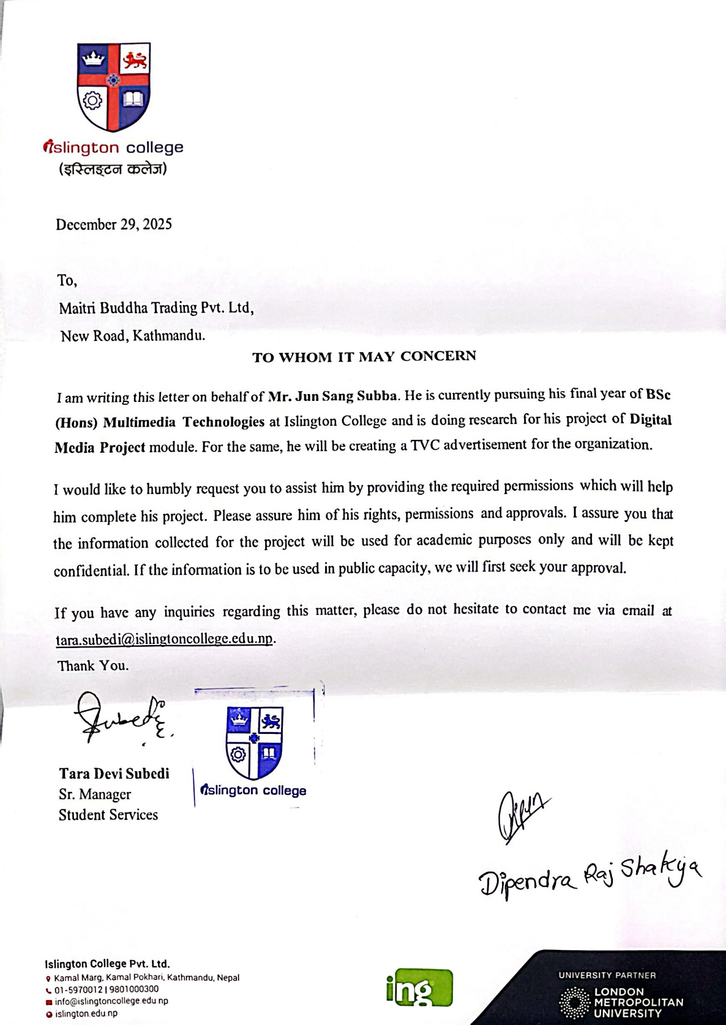
Figure 18: Proposal Letter to Client
With the help of Islington College, a proposal letter regarding the DMP to the client was made and delivered physically, which later the client approved.

1. Project Title
MBT Product Shoot Television Commercial (TVC)

2. Research Questions
“How consumers perceive a product and its desirability from the visual language in a short-form television commercial”
This project dives into how consumers view a product and what makes it desirable, all through the emphasis of visual storytelling in a short TV commercial. It discuses in on the use of professional cinematic techniques, like camera angles, lighting design, controlled motion, and editing, to showcase a product’s features and give it a premium, attractive vibe. By looking at visual hierarchy, the research explores how specific elements draw the viewer’s eye, while motion and pacing play a crucial role in keeping them engaged and stirring emotional responses. Plus, it examines how mood lighting and colour choices contribute to setting the tone, boosting appeal, and reinforcing brand identity.
Ultimately, the project seeks to show how these visual strategies can effectively grab the audience's attention, evoke feelings, and convey the product’s value and quality, even in the short span of a brief TV commercial.

3. Treatment
The upcoming Product Shoot TVC is set to have a minimalist vibe, putting the product front and centre in a 15–30 second spot. Rather than weaving a narrative, it will emphasize visual hierarchy, rhythm, and mood to highlight the product and strengthen brand identity. With gentle camera movements like slow push-ins and lateral slides, along with macro and close-up shots, texture, surface details, and quality will be showcased. Selective slow-motion will draw attention to key moments, enhancing that premium feel.
Controlled lighting, along with carefully crafted highlights, shadows, and colour grading, will maintain consistency and reflect the brand’s essence. The TVC will wrap up with a striking hero shot, presenting the product in a clean layout to boost recognition. Every visual and technical choice is made to capture attention, elevate desirability, and convey the product’s premium quality.

4. Resources
Software:
- Adobe Premiere Pro: video editing
- DaVinci Resolve: colour grading and consistency
- Adobe After Effects: motion graphics, call-to-action, VFX
- Adobe Audition: audio enhancement and balancing
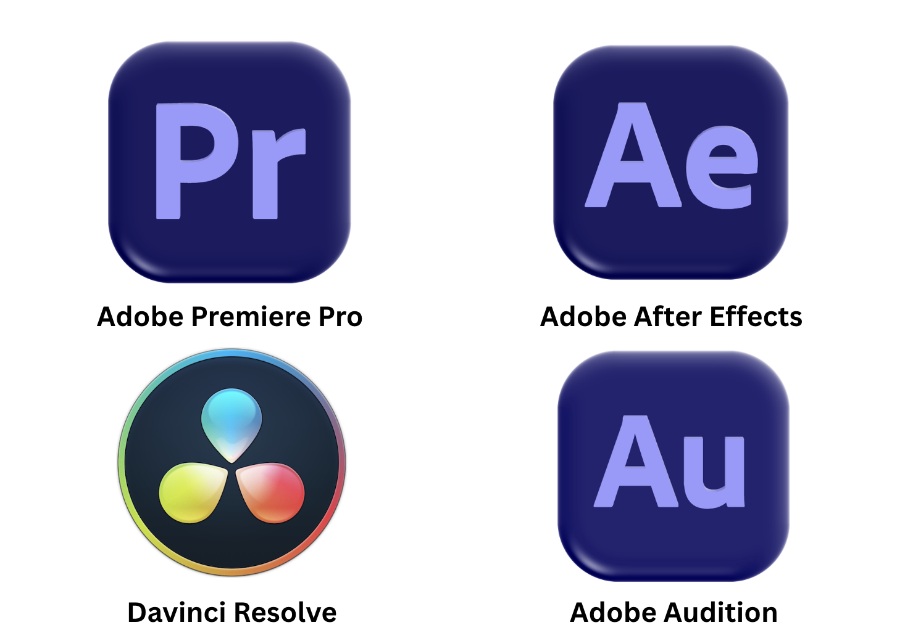
Figure 19: Software Used for the Project
Hardware:
- MacBook Pro M4 Pro: for editing, colour grading, and post-production
- iPhone or Mirrorless Camera: filming high-quality footage

Survey / Feedback Collection:
The utilization of both direct and indirect feedback will be conducted.
- Google Forms: collect digital feedback, visual appeal, effectiveness
- Door-to-door: for professional feedback and finalization

Figure 20: Google Forms for Indirect Survey
Distribution:
- YouTube: main platform for sharing the TVC
- Google Drive: link sharing for feedback collection

5. Contribution of Others
Client Side:
In the production phase, friends and volunteers will be used to pitch in with small tasks, like helping set up the camera, managing the lighting, or even acting in some scenes. Their contributions are invaluable for keeping everything running smoothly, but ultimately, the big creative and technical choices are to be made.
Personal Side:
When it comes to post-production, all the footage will be captured during the product shoot and then edited, ensuring originality. No outside organizations will contribute any footage, which means the content will stay true to the project's creative vision. The editing process will focus on picking the best shots, fine-tuning the pacing, and applying some basic colour correction and sound design to boost both the visual and audio quality. Feedback from peers will be considered during the refinement phase to spot areas for improvement in transitions, timing, and overall clarity. This collaborative effort will help polish the final cut while keeping the original creative direction intact. The result is designed to meet both academic standards and professional production quality.

6. Evaluation and Testing

6.1 Evaluation
The final Product Shoot TVC will be assessed through a mix of audience feedback and expert reviews to measure its overall impact. Audience insights will be gathered from at least 20 participants using a Google Form questionnaire, which will be shared digitally via messaging apps and social media to make it easy for people to respond and to capture a diverse range of opinions. The questionnaire will have a brief introduction outlining the evaluation's purpose, followed by structured questions that focus on key elements of the TVC, such as visual quality, editing pace, clarity of product presentation, and how effectively the visuals convey the intended mood and brand message. To make it simple to analyse, a 1–5 rating scale for responses will be used.
On top of audience feedback, five individuals with backgrounds in filmmaking or media production will be selected to provide expert evaluations. These experts will receive a separate structured form with more technical questions, and brief follow-up discussions will be taken to clarify their answers if needed. Once all the responses have been gathered, Google Forms’ automatic data will be used to review audience ratings, while expert feedback will be analysed qualitatively to pinpoint common strengths and areas for improvement. This combined approach ensures that both general audience perceptions and professional insights when evaluating the effectiveness of the final Product Shoot TVC will be captured.

6.2 Testing
The testing phase is all about making sure that the final music video not only looks fantastic but also sounds amazing on every device. Here are some of the tools and checks which were done:
Colour Grading:
- Checked over multiple devices like iPhone 16 Plus, iPhone 12 Pro Max, MacBook Pro M4 Pro, Samsung TV
- Checked Brightness, Contrast, Saturation Levels, Banding of Video
- Ensured colours are same throughout the devices
Audio Testing:
- Checked on various devices like iPhone 16 Plus, iPhone 12 Pro Max, MacBook Pro M4 Pro, Samsung TV
- Checked consistency of the levels and peaking of the audio
- Checked whether if there are distortion of audio
Video Quality Testing:
- Checking the resolution and whether it is pixelating or not
- Verified the resolution and sharpness consistency
- Verified whether it loses video quality or not

7. Bibliography

Adobe, n.d. What is cinematography? Learn the basics and techniques.. [Online]
Available at: https://www.adobe.com/creativecloud/video/production/cinematography.html?utm_source=chatgpt.com
[Accessed 9 12 2025].
StudioBinder, 2025. 50+ Types of Camera Shots, Angles, and Techniques. [Online]
Available at: https://www.studiobinder.com/blog/ultimate-guide-to-camera-shots/
[Accessed 9 12 2025].
Filmbaker, 2025. Cinematography - The Art and Craft of Lighting and Lens for the Moving Image. [Online]
Available at: https://www.filmbaker.com/blog/cinematography-lighting-and-lens
[Accessed 9 12 2025].
Studio Binder, 2020. Three-Point Video Lighting: Key, Fill, & Backlight Setup Guide. [Online]
Available at: https://www.studiobinder.com/blog/three-point-lighting-setup/
[Accessed 9 12 2025].
Ambrose, D., 2022. High Key Lighting And How To Set It Up. [Online]
Available at: https://www.lightstalking.com/bite-size-tips-what-is-a-high-key-lighting-and-how-to-set-it-up/
[Accessed 9 12 2025].
Unknown, 2014. Unit 3 - Ideas and Concepts in Art and Design. [Online]
Available at: https://unit3laurenclancy.blogspot.com/2014/03/low-high-mid-key-lighting-stages.html
[Accessed 9 12 2025].
WIFITALENTS, 2025. Emotional Marketing Statistics. [Online]
Available at: https://wifitalents.com/emotional-marketing-statistics/?utm_source=chatgpt.com
[Accessed 29 12 2025].
Harvey, S., n.d. The power of emotional marketing: Once more with feeling. [Online]
Available at: https://fabrikbrands.com/branding-matters/brand-marketing/the-power-of-emotional-marketing/
[Accessed 29 12 2025].
Smashing Bros, 2021. Color Theory for Designers, Part 1: The Meaning of Color. [Online]
Available at: https://www.smashingmagazine.com/2010/01/color-theory-for-designers-part-1-the-meaning-of-color/
[Accessed 29 12 2025].
Matiash, n.d. Photographers need to stop color grading the wrong way. [Online]
Available at: https://www.matiash.com/blog/lightroom-color-grading
[Accessed 30 12 2025].
Behavioral Design Academy, n.d. Colour Schemes. [Online]
Available at: https://www.behavioraldesign.academy/color-psychology/color-schemes
[Accessed 30 12 2025].
Heckmann, C., 2021. What is a Film Cut — Editing Cuts and Transitions Explained. [Online]
Available at: https://www.studiobinder.com/blog/what-is-a-film-cut-definition/
[Accessed 30 12 2025].
Binder, S., 2024. Match Cuts & Creative Transitions with Examples – Editing Techniques. [Online]
Available at: https://www.studiobinder.com/blog/match-cuts-creative-transitions-examples/
[Accessed 30 12 2025].
McGlinchey, T., 2024. J Cut vs. L Cut: Why and How to Use Them in Your Videos. [Online]
Available at: https://artlist.io/blog/j-cut-vs-l-cut/
[Accessed 30 12 2025].
Winter, D., 2024. The Art of Mixing and Mastering Audio for Video. [Online]
Available at: https://lwks.com/blog/the-art-of-mixing-and-mastering-audio-for-video#:~:text=Mixing%20is%20blending%20individual%20audio,contributes%20effectively%20to%20the%20story.
[Accessed 30 12 2025].

8. Appendix
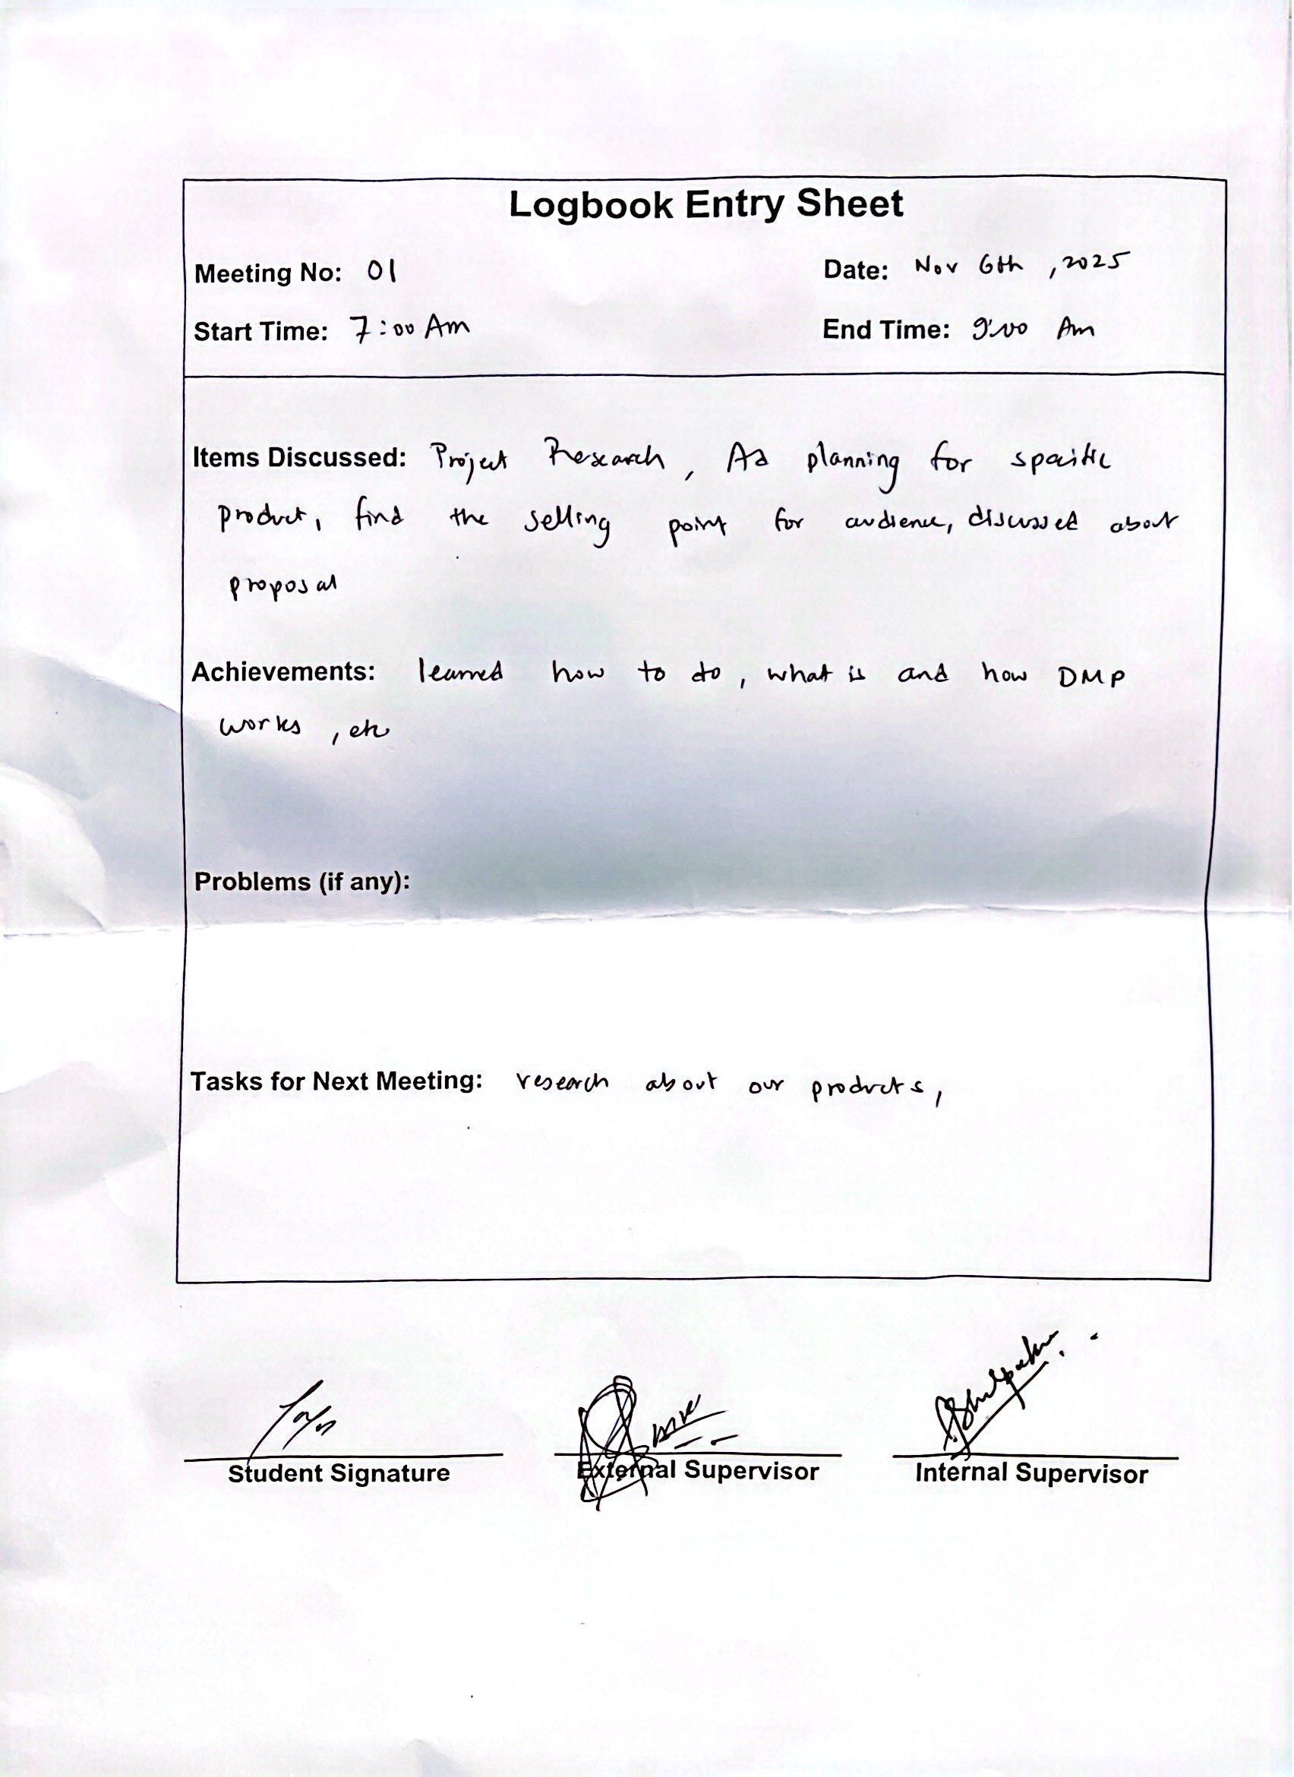
Figure 21: DMP Session 01
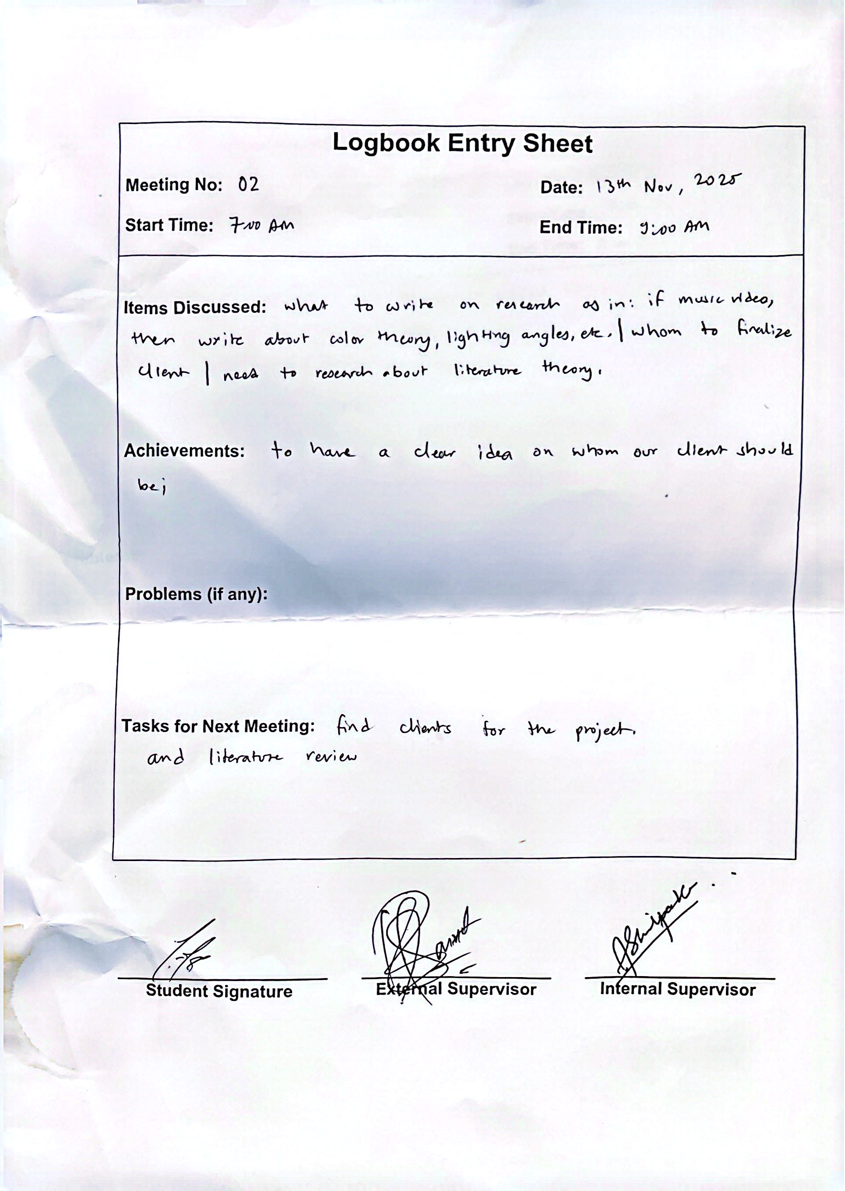
Figure 22: DMP Session 02
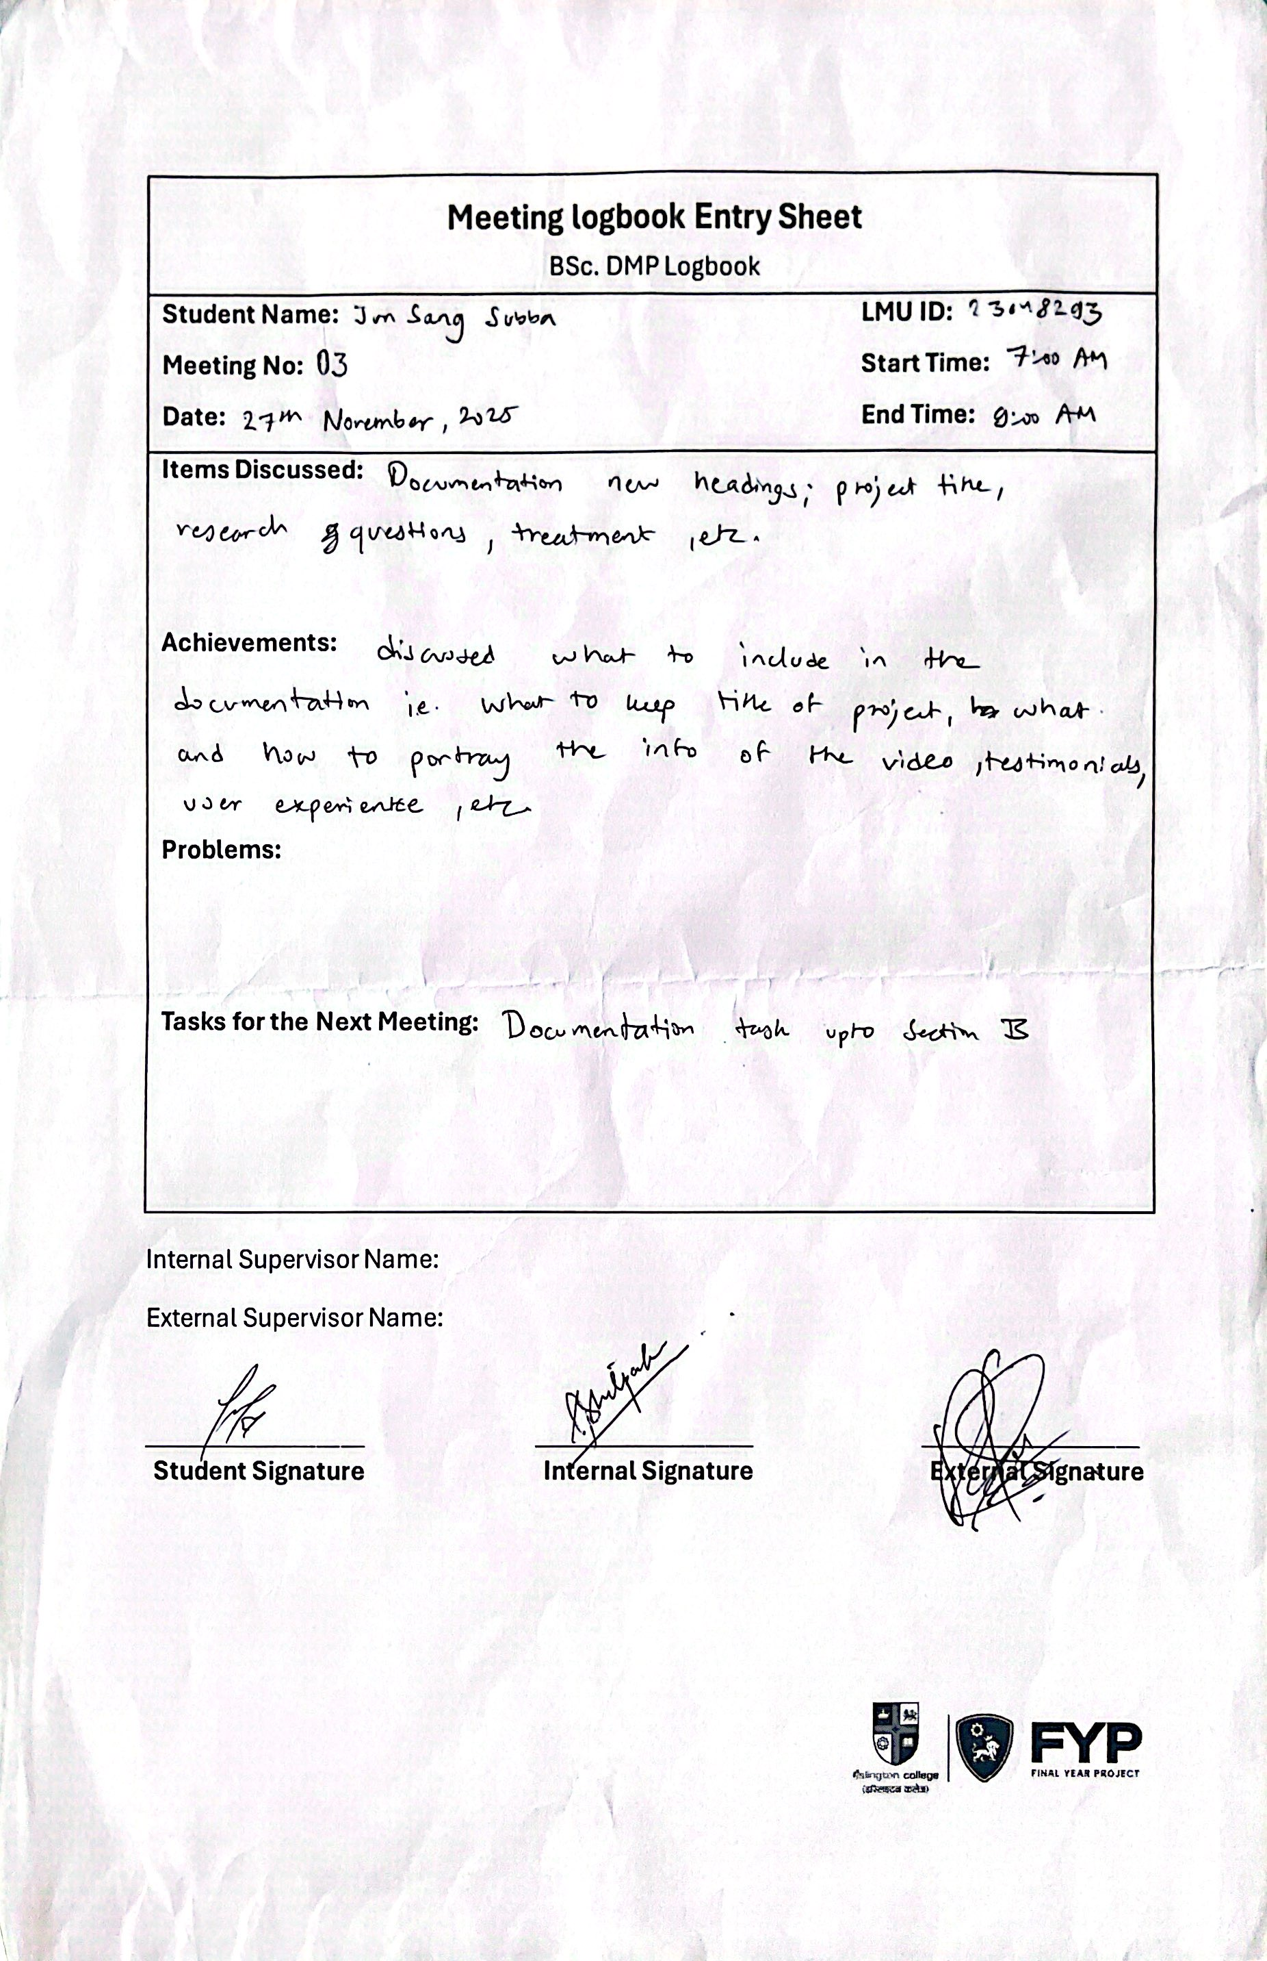
Figure 23: DMP Session 03
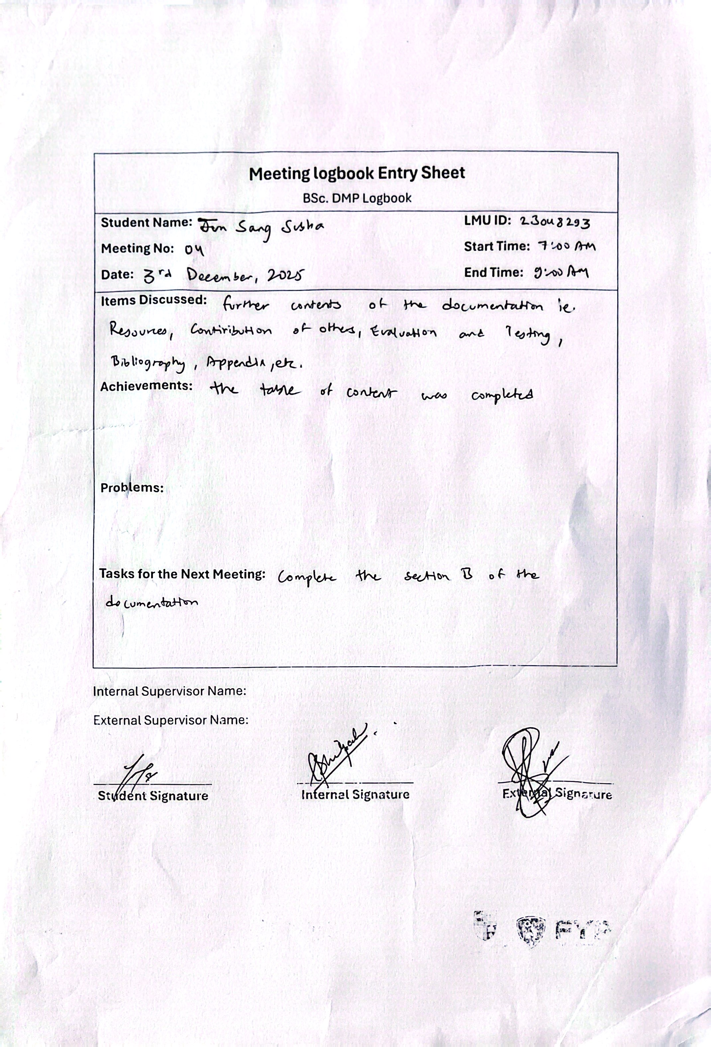
Figure 24: DMP Session 04

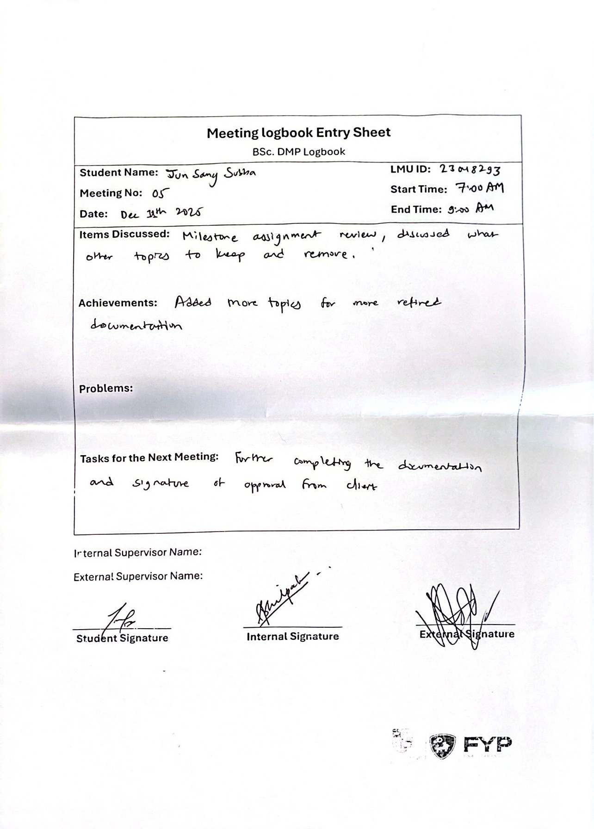
Figure 25: DMP Session 05

